GEARI
Gender Equality in African Regional Institutions

(A CIDA-funded Project)

Report on GEARI Mission Three
to the Nile Basin Initiative (NBI)

22-26th June 2009

Prepared by
Nancy Spence, Lead GEARI Gender Consultant

Foundation for International Training

TABLE OF CONTENTS

Executive Summary 03
Backgrounder on GEARI/Outputs of Mission One and Two 04
TORs for Mission Three/Scope of Work 07
Mission Three Objectives/Methodology 08

Mission Three GEARI
Workshop Business Meeting Proceedings 08
Workshop on GWG TOT Training 09 Application of training to work plans 12
GWG Progress and Implementing the (revised) Action Planning 14
Debrief with Senior Management 15

APPENDICES xx
APPENDIX 1 Revised Agenda Business Meeting xx
APPENDIX 2 NBI Revised Action Plan xx
APPENDIX 3 Revised Agenda: Training xx
APPENDIX 4 Participant List for Training xx
APPENDIX 5 Opening Speech by GEARI xx
APPENDIX 6 Training materials incl. power points xx
APPENDIX 7 Evaluation Exercise xx

EXECUTIVE SUMMARY

GEARI Mission Three to the Nile Basin Initiative took place from 21-26th June in Nairobi Kenya. It consisted of two meetings: a business meeting with the core gender Working group formed in 2007, and a larger training workshop of core GWG members joined by staff from many areas within NBI ,such as Human Resources, finance, administration, M & E and some senior management.

The Business meeting was designed to cover off immediate priorities facing the Gender Working Group. This included the development of Terms of Reference for an upcoming Gender policy to be developed at NBI targeted for October 2009 in order to have it approved by the TAC which meets in late October. It also was to review the draft Plan of Action, created in 2008 and make it simpler and more relevant to the current needs at NBI, This allowed for a reduction in its size and content as many of the aspects in the 2008 Action Plan would now be incorporated into the Gender Policy being prepared. The business meeting ended with those two important outputs and a revised Action Plan that is wholly owned by NBI. See Annex 2 for details/

Training began Day Three with the opening by a well known gender advocate from the Kenyan government, MP Millicent Odihambo whose rousing opening speech created both insight and humor to the participants. Day One of training largely was sensitivity training to both the concepts and stereotypes of gender as well as the need for taking a gender lens to see the real situation for women and girls, given the discriminatory legal ands social practices in Africa and elsewhere. A gender analysis tool to influence policy was then applied to two group case studies that looked at how two governments, one in South Africa and one in Uganda had successfully integrated gender into their water policies and procedures. Day Two was devoted to applications: gender in the project and program cycle followed by how to gender mainstream within institutions setting up accountability structures such as a gender policy, gender budgeting and gender required in the approval processes. Several examples from Africa were illustrated to demonstrate how these have been applied by others such as the African development bank and SADC. Day two ended with a staff dialogue over workplace issues, after having viewed some model workplace policies. The final day transferred to the participants to come up with what they had learned and how those could be applied to their various programming and administration areas. A role pay was enacted to demonstrate the traits of gender advocacy. A demonstration was given for future publications and resources, useful websites and networks and another was mounted on aspects of training. A CDROM was distributed to all with a compete set of training tools and workshop proceedings alongside certificates for 28 participants.
Since Mission Two, many significant steps had been taken at NBI to embed gender’s gender focal point ( interim) had been named awaiting a full time position set for January 2010. Over a half million dollars has been allocated to gender activities form CBSI funds until December 2009.
A Gender Policy has been agreed to in the ISP process and Terms of Reference are being drawn up for the development of this policy set for October 2009. The Gender Working Group continues to thrive with increased vigour, having met for the third time in this mission. Congratulations NBI.
The final GEARI Mission is set for the last week of January 2010 for monitoring purposes and assisting in developing good practice

NBI Participants to the
GEARI Mission Three
Training Workshop
Nairobi Kenya
June 2009

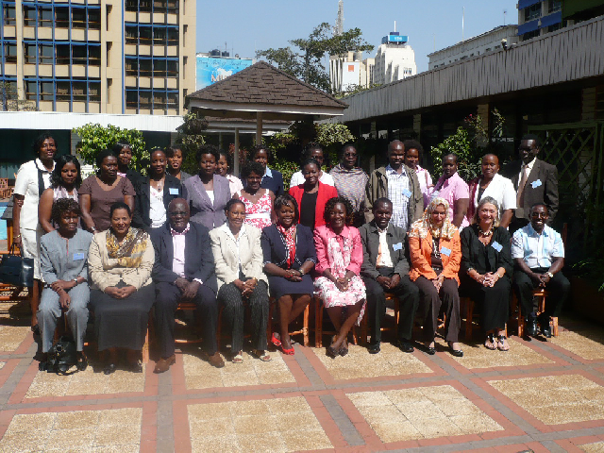
BACKGROUNDER ON GEARI
WHAT IS CIDA- GEARI?

Backgrounder: The Gender Equality and African Regional Institution Project :Canadian Internitional Developmemt Agency

Description
CIDA’s Pan-Africa Program supports the development of institutions in Africa to address shared development challenges in areas such as agriculture, environmental sustainability, governance, etc. In keeping with the principles of international best practices and CIDA’s own policy directives, developing the capacities of Pan-African institutions to mainstream gender equality imperatives in their policies and programs is an integral component of the Program’s approach to institutional capacity development. Accordingly, CIDA initiated the Gender Equality and African Institutions Project (GEARI) to assist key Pan-African partner organizations - between them, the Nile Basin Initiative (NBI) – to integrate gender equality results into their analysis, planning, implementation and monitoring of their policies and programs.

To this end, the Pan-Africa Program offered its partner institutions technical support and expertise to assist them with their gender equality mainstreaming goals. The GEARI Project has as its aims to support the development of strategies to institutionalize gender based analysis and gender equality results within the institution. This would include: gender needs assessments throughout the organization; capacity development/training; continuous learning and gender equality capacity building; the development of gender equality action plans for each institution based upon their perceptions and needs; gender equality monitoring and evaluation as required by the institutions. Under this Project, a team of Canadian and African gender specialists assisted the Nile Basin Initiative to develop this capacity for gender-mainstreaming.

This team of international gender specialists followed a participatory approach in all stages of interventions by ensuring the involvement of the institutions’ representatives including heads of the institutions; senior management; staff; and internal gender specialists, facilitators and project persons. At the beginning of the project, the GEARI team consulted with the respective Heads of the institutions to establish a Gender Working Group in each institution. This gender working group served as a task force for the implementation of the project’s activities.
The overall expected results of the Gender Equality and African Regional Institutions Project are:
A gender audit and/or needs assessment of the four organisations supported by the Pan-Africa Program; ( completed in GEARI Mission One, September 2007)
Gender equality action plans for the four institutions including gender equality results statements and gender equality capacity development plans initiated ,(GEARI Mission Two October 2008)
Continuous learning and mainstreaming tools for achieving gender equality with Gender equality training and capacity building; ( GEARI Mission Three June 2009) and
Follow-up monitoring and evaluation of gender equality plans.(Mission planned January 2010)

OUTPUTS TO DATE

GEARI MISSION ONE REVISITED September 2007

In September 2007 an inception mission was carried out for the Gender Equality and African Regional Institution Project (GEARI). During this mission the GEARI team focused on presenting the GEARI project to the senior management and on preparing the Participatory Gender Audit. Our main concern was to ensure ownership of the process by the participants in the preparatory phase. During this first GEARI mission, the GEARI team worked with NBI in setting up a Gender Working Group (GWG) and gathered – with the GWG – initial information about NBI’s structure, style, system, staff, policies, programs and programmes to gain a clearer understanding of its nature, and to select the most appropriate approach for gender mainstreaming.

The methods used for the Gender Audit were agreed on by the Gender Working Group (GWG), set up for this purpose and composed by NBI representatives. These included questionnaires, semi-structured interviews, focus groups, basic training sessions on audits and gender mainstreaming, and a documentation and policy review.

To support and accompany the setting up and the work of a Gender Working Group (GWG):

- We developed an initial training session (for the GWG) in order to build a common vision of gender mainstreaming);
- We discussed the gender needs assessment process (goal, objectives, methodology, tools, etc.);
- We agreed on the tools needed to facilitate a participatory approach to the gender audit throughout the institution (questionnaire, number of focus groups and with whom, management, program, support staff, and selected NBI women’s conference representatives as a focus group);
- We prepared a document on the GWG’s roles and responsibilities, mechanisms of participation, mandate, accountability and implementation steps.
- We developed an agreed upon work plan for the first year with expected results and indicators, specific steps and activities for the in-between-missions-period.
- We completed an LFA of expected measurable results for NBI

Several individual interviews were also carried out during the inception mission, with management, program and support staff to have an initial sense of the organization, its structure and challenges. A questionnaire was revised and finalised with the GWG to be more relevant to the NBI context. This survey was distributed, completed and collected in November 2007. It was distributed to all NBI staff and answered by staff themselves, for confidentiality. A draft report of the NBI Assessment was submitted to NBI management in March 2008. A summary of this with power point findings was presented to the GWG in October 2008 at the Second GEARI Mission.
GEARI MISSION TWO REVISITED: October 2008

The GEARI Mission met with the Gender Working Group to validate the findings of the audit /assessment and to work with the GWG to complete and finalise recommendations for an action plan and a capacity building plan for future training needs planned for GEARI Mission Three.
From October 02-04, NBI Gender Working Group members participated actively in the formulation of an Action Plan for Advancing Gender Mainstreaming within the NBI. These were drawn from recommendations made by NBI staff in the questionnaire that formed the audit and previous recommendations made by the CBSI-organized Nile Basin Women’s Forum in 2006. These recommendations were formulated into a results-based Gender Action Plan for 2009-2011, and presented to NBI senior management at the conclusion of Mission Two. It detailed expected results, activities to be undertaken, indicators to measure progress; a budget; timelines; responsibilities and training required for staff to meet these results (see chart below).

The conclusions of GEARI Mission Two were that, despite all the good intentions and committment to gender equality principles at NBI , there would be no significant progress on gender mainstreamning at NBI without a gender expert hired internally to lead this process forward. The GWG has been put in place and the Action Plan detailed tasks that needed action particularly the first year. There was seen an urgent need for a gender expert to drive this Action Plan and lead the Gender Working Groups .This GWG would also monitor the Action Plan and allow for systematic reporting on the results of the Gender Action Plan over three years, and produce the evidence of concrete results at NBI. A number of opportunities were identified ( TAC meeting in October 2008 etc) as potential entry points to approving the required funds to enact these plans.

GEARI MISSION THREE:

1. TORS and EXPECTED RESULTS

The principle activity of mission Three was to train relevant staff at NBI in gender mainstreaming and set up a continuous learning cycle in which resources would be readily available for staff. It was broken into :
- A Business meeting with core GWG members, held to simplify and prioritize the Gender Action Plan with agreed upon urgent next steps. An NBI Staff Training plan revised and finalized by the GWG.
- An NBI Staff Training plan revised and finalized by the GWG.
- A Training Workshop with the GWG core and supplementary members carried out.
- A set of learning resources made readily available to assist in further training

2. SCOPE OF WORK AND ACTIVITIES FOR MISSION THREE: TRAINING

The assignment for the International GEARI Gender Team includes was not necessarily limited to the following tasks:

4.1 In Canada and Entebbe prior to the field visit

With the African Gender specialist:

- Identify and contract a new African gender consultant experienced in the water sector
- Be updated with NBI plans for gender in ISP process and progress to date.
- Agree upon a date for the Mission Three ( June 22-26th 2009 in Nairobi Kenya)
- Detailed TORs elaboration of Mission Three shared.
- An agenda prepared for a business meeting with core GWG members
- A Training workshop developed into a programme and circulate it to NBI fro approval
- Communication and liaison with FIT and with CIDA.
- Mission logistics preparation & completed.

4.2 In the field

- Liaison with CIDA’s representative in Nairobi to share mission’s objectives.
- Coordination and preparation with the African Gender Specialist at the beginning of the mission.
- Undertake the Business meeting 21 & 22 June 2009
- Undertake the Training workshop 21 & 22 June 2009
- Debrief with NBI staff M & E, Gender focal point follow up in Entebbe )
- Communicate key findings to ED (Entebbe)

Back in Canada

- Electronic debriefing with CIDA Representative in NBI and headquarters at the end of the mission.
- Briefing with FIT and CIDA (conference calls).
- Finalization of the Mission Report circulated.

3. NBI Mission schedule
.  Monday-  June 22 | - Business Meeting Day One with GWG
Tuesday  June 23th | - Business Meeting Day Two with GWG
Wednesday June 24 2009 | - Training day One
Thursday June 25th | - Training Day One
Friday June 26th | - Training Day Two
Sunday June 28th | - Travel to Entebbe
Monday June 29th | - Debrief in Entebbe with Monitoring and Evluation, HR
Tuesday 30th, 2009 | - Debrief in Entebbe with Gender focal Point
Wednesday 01 2009 | - Debrief in Entebbe with Executive Director  - Departure fo International Consultant

4. METHODOLOGY : AN UPDATE, A BUSINESS MEETING AND A TRAINING WORKSHOP

Following instructions from NBI, the Business meeting and training workshop were moved to Nairobi Kenya for cost- effectiveness. The Business meeting was planned to update progress and establish priorities for NBI to ensure gender mainstreaming took hold at NBI.
4.1 UPDATE ON PROGRESS AT NBI

Since Mission Two, many significant steps had been taken at NBI to embed gender.

- After some negotiation with donors, the ED appointed Juliet Nakasagga, the NBI Librarian to act as an interim gender focal point who has capably led the GWG into its Third GEARI Mission meeting.
- A sum of approx $US 550 of CBSI funds were available for gender activities until December 2009.
- A gender policy has been accepted in the ISP process and needs to be developed particularly while there were funds to support it and to be taken to the TAC meeting in October 2009 for approval and then NILSEC for endorsement
- The Executive Director NBI confirmed a new permanent position at ISP for a senior gender expert to be enacted beginning 2010.

Congratulations NBI

4.2 GWG BUSINESS MEETING PROCEEDINGS June 22 23rd

Core GWG members: Juliet Nakasagga (FP);Gordon Mumbo (CBSI-RPM); Intisar Salih (NTEAP-GWG); John Ogwang (NSEC-ME); Hamere Wondimu (SVPC/O); Willy Kayondo (NSEC-HR); Jane Nabunya (CBSI-GWG); Josephine Lwasa (NSEC-FINANCE); Jane Kisakye (NTEAP-GWG); Emerita Mugorewicyeza (Consultant); Salah Salih (ENTRO-GWG absent); Peter Kanyi (NELSAP-GWG); Hellen Natu (SDBS-GWG).
Canadian High Commission staff also attended as observers for the Business meeting and Patricia Munayi the Gender Advisor at the CCO attended the training 24th to 26th.

At the Business meeting, attended by core GWG staff, it became apparent that the original agenda ( see Annex One ) needed to be simplified to meet the two key priorities that the GWG wished to see go forward immediately:

- Detailed TORS for a consultant to develop a gender policy
- Simplification of the Gender Action Plan down to two areas of immediate priority. All previous activities were deemed part of the new Gender Policy so could be taken from the Action Plan and form part of the gender policy enactment:

(i) setting up the structures for legitimizing gender at NBI through a gender policy and the “institutionalizing of the GWG”. The TORS will be enacted immediately following NBI procurement processes and it is hoped that a consultant will be hired by 15th July and the gender policy draft produced by 15th October. For confidentiality reasons, the TORS are not being circulated in this report.
(ii) the Gender Action Plan had numerous actions in it best handled under a gender policy. For example gender action plans in all future projects or the enactment of gender budgeting was deemed best suited within a gender policy.

So the Action Plan was reduced in size and scope but was fully owned by NBI.This revised Gender Action Plan appears as Annex Two in the Appendices. A Training Plan within it was updated to include 4 kinds of NBI future training:

- TAC training October 2009
- Project staff training with sub training themes identified in : HR, gender budgeting, gender in project cycle and LFA/indicators of gender. This is set for 2010 following the gender policy adoption.
- National Gender Sensitivity Training for NBI national level GOW partners
- Regional level Sensitivity Training for NBI stakeholders

NBI is advised to use the existing CBSI funds for gender to begin to enact the customized NBI tools for this training

5. THE TRAINING OF TRAINERS WORKSHOP PROCEEDINGS June 24-26 2009

Day Three to Five of the GEARI Mission (June 24-26th) consisted of three days of training 27 core and non-core staff at NBI. The participants were from many of the levels at NBI and drawn from many areas (Nelsap, Nile Sec, NTEAP, ATP, RTPT, EWUP) all different entities of the NBI. Regrettably full representation from the SAPS (delivery of projects/operations) lacked reps from ENTRO, who had a concurrent meeting in Addis.
The schedule of training sessions appears in Annex Three of the appendices. Full sessional details and all power points are included in Annex 6. A further detailed training report will be provided to NBI by Ms Annabell Waititu , the GEARI trainer and staff at the Gender and Water Alliance (Nairobi).

Brief highlights will be reported below. There were nine sessions in all, culminating in two panel and staff dialogues to apply training to NBI .

OPENING Session (9:00 AM Wednesday June 24th 2009)
The training was opened by Ms Millicent Odihambo, an energetic female MP from Nairobi who gave a riveting opening speech that called for gender equality in which men were more sharing (i.e. Corinthian men) and yet women were expected to behave in a manner of submissiveness that belied their talents and accomplishments. She also expressed the need for gender mainstreaming to be adapted at and relevant at all levels, and include the tea vendors and cleaning staff at organizations.
Following the MP’s opening , GEARI trainer Nancy Spence summarized objectives of training and heard from participants about their expectations on cards [posted on th wall. A group picture ensued.

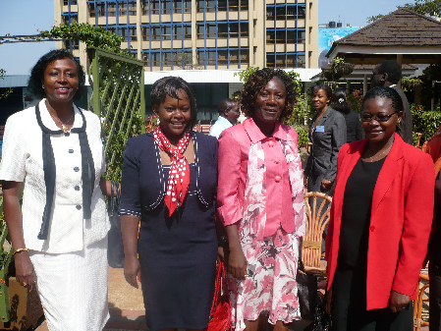

Keynote speaker: MP Ms Millicent Odihambo (second left) greets NBI staff and Canadian Cooperative Office Gender Advisor, Patricia Munayi. Nancy Spence and Juliet Nakasagga, the gender focal point at NBI.

Session Two
Session two began with a number of stereotypical statements in a true false ice breaker. That followed with a look at typical concepts in gender mainstreaming with examples related to IWRM. A case study on demand driven applications in water and sanitation presented the constraints women face in particular in IWRM. Discussion showed the need to target women directly for their inclusion as beneficiaries in projects and outlined the typical “ special measures” required for this to occur. Women face “Achieving voice” as laws and discriminatory practices prevent women’s voices from being adequately heard. Gender roles produced by culture and religion also featured prominently as to how this could divert project goals. It was concluded that demand- driven projects often overlook women’s needs in community processes. Ways to overcome this were reviewed.

Session Three looked at adopting a “gender lens” to see the reality on the ground for women Things are not always as they seem and myths and stereotypes perpetuate and abound which ar harmful to projects and to women. It requires gender analysis ( a tool greatly deepened in Session 4) to clearly see the limitations on women. Ms Spence demonstrated this with an oversize pair of “gender lenses” and had several demonstrations of this myth related distortions of reality. (The USAID PEPFAR project enforcing ABC in HIVAIDS was used as a tool to see how this impacted negatively upon women etc). Participants filled in their own gender lenses and read these out. A practical case study followed in group work that showed how a gender lens was an essential feature of gender mainstreaming.

Session Four concerned “Influencing Policy” and deepened the need for gender analysis. Ms Waititu presented a tool to undertake influence policy using gender analysis (i.e. access and control matrices etc ). Two group case studies looked at how two governments, one in South Africa and one in Uganda had successfully integrated gender into their water policies and procedures. Discussion drew out the need to drill down into national policies to see how regional ones could be harmonized with national gender action plans. The upcoming Cooperating Framework Agreement ( CFA) at NBI was noted as a place where gender needed to be more evident. If not in the 5 pillars, then as “gender responsive” in the CFA strategies area. It was suggested that simply assuming the title Integrated Water resource Management (IWRM) implied gender was seen as not sufficient to guarantee gender equality aspects.

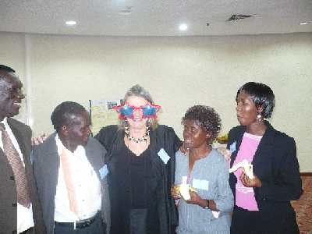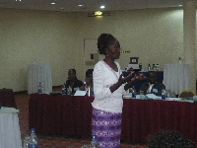

“Wearing a gender lens” to see gender realities!

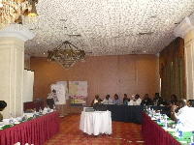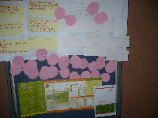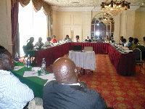
Plenary Participants feedback Staff dialogue

Session Five looked at gender mainstreaming in the program and project style. Ms Waititu began with the elements of a gender framework for assessing projects at the identification stage to see what roles were performed by whom and under what conditions ( i.e. activity profile, access and control of resources and factors that affect these) and how they play out differently for women and men. A Social Background Analysis (SBA) was presented that showed all stage of the project cycle, i.e. (Identification; consultation with stakeholders, formulation, implementation, monitoring and evaluation) at each stage. It was suggested a checklist be prepared for gender inclusion in each stage and often also required “special measures” to enact. It was felt an NBI “ customized” project cycle and an NBI oriented set of guidelines or indicators for gender mainstreaming at each stage would be required. It was pointed out that senior management needed to be very aware of these gender needs particularly in approval processes of projects (i.e. proposal stage) had to be raised at SAPS project manager level, at Steering Committee membership level and at TAC level. They need sensitivity training to ensure these gender entry points are appreciated . It was felt the GWG could serve a useful purpose here -- ensuring guidelines were developed that could be monitored, especially in M & E logframes. There was a discussion about performance appraisals. It was felt all of these issues and areas would need to be clarified and developed in a gender policy for NBI.

Session Six analyzed the logical steps required in institutionalizing “gender” within NBI. This covered not only the roles and responsibilities of senior management, the GWG and all staff. It explained the need from a workplace policy that should be engendered. It examined the steps of institutionalizing policy enactment within structures and processes at NBI but using a SADC model fro structuring and positioning and gender budgeting, using an Asian Development Bank model along with an African Development Bank model. Examples were passed around demonstrating the codes and categories required for project classification to follow the money and discern the degree to which the NBI would be accountable to gender in resource allocation.

Session Seven became a staff dialogue about the workplace, using a chart that outlined typical issues and suggested actions to take in engendering a NBI organizational culture-in the workplace. After examining many best practices developed in gender policies related to the workplace by the CGIAR network ( based at ICRAF in Nairobi) this allowed for a simulated tool, created by them, available to NBI staff for follow up on the Internet. The tool described an internet based wheel that had numerous model policies in diverse Human Resource areas. This was felt particularly useful to the engendering of human resources by the HR Division at NBI.

Key issues that emerged from the staff dialogue to make NBI a more women and men friendly workplace were listed as :
- the need for a crèche for young parents (NBI staff would contribute all- just eed a space),
- flexi hours, including earlier departure on Fridays ( but all men and women maintaining equal hours overall through the week);
- a Disciplinary Ctee formed with a staff code of conduct to regulate behavior considered inappropriate to the workplace,
- the need for a code of conduct to be established at NBI, harassment and bullying coverage;
- team building and stress counseling,
- an orientation program for new staff with diversity training ( inclduign gender),
- Gender responsive tools for hiring /staffing recruitment/practices,
- a quota system in place with benchmarks for gender balance at all levels
- a Senior Managers Forum to address these issues and manage the implementation of this process at NBI

Session Eight became a “Training techniques” --designed to assist NBI in creating their own training. An advocacy tool was done by role playing two gender focal points approaching senior management in a dialogue. The outcome of it identified the need for brevity clarity and forcefulness in gender advocacy dialogues.
A Training Plan was finalized which identified four respective training needs to be met at NBI. This included:
- sensitivity training for Sr. Managers,
- project training for SAPS staff ( with sub training elements identified for human resources, communications, M & E and gender budgeting (for finance).
- a desired National workshops to push the gender policy and strategy
- Regional level workshop(s) for stakeholders at NBI ---particularly for national level staff to get up to speed and harmonize actions.

It was suggested that NBI begin to develop these customized training tools while they had the funds up until December 2009. TAC training was suggested for the end of October to help push through the Gender Policy.

Scenes from GEARI Mission Three training

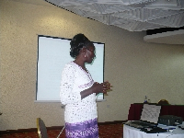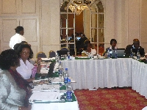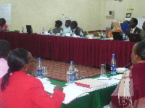

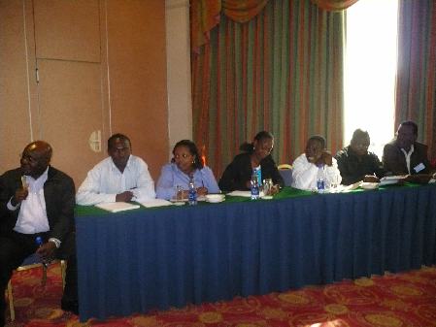

A Panel demonstrates new learning from training CGIAR workplace tool

Session Nine was a panel discussion by various elements of NBI ( with staff from Sr. Management, M & E, H.R. , Admin, Finance, Operations, etc ) to see what they felt they had learned and how they could apply these to their respective areas as “next steps to apply the training to their respective work plans. The results are described in the following section under “Application of training to workplans”.

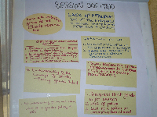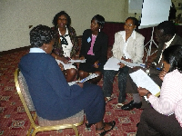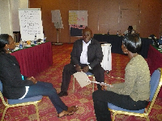

Session ten looked at resources that were available for all staff to further develop their skills. These were included in a CDROM of all training materials including power points, distributed to all staff at the conclusion of the training, along with a certificate of participation. It elaborated on the range of publications, manuals, checklists and internet sources and websites for addressign gender in IWRA. Again the need for customized NBI tools for sensitvity training and project staff training was highlighted and to be undertaken ASAP so that these training tools would be ready to be able to start this training as soon as the NBI gender policy was enacted. This is expected by late November. Training will begin with the TACS in late October with NBI staff in early 2010.

The last session eleven evaluated the training and also spoke to individuals’ commitment to take this training and apply it to their workplans. These are summarized in more detail in Annex 7.

6. EVALUATION STATISTICS

See Annex 7 for further details

1.LOGISTICS: Excellent20%;VeryGood 40%; good 40% Fair4% poor 0%
2.QUALITY OF TRAINING:Excellent 25%Very good 47%,Good 28% Fair 0% Poor0%)
18 out of 21 said the training was useful and could be alplied to their work. Three said potentially.

Topics considered relevant to to participants were identified as follows:
- The concepts of gender mainstreaming gender ( 5)
- Institutionalizing and strengthening GM in NBI (4)
- Gender budgeting (5)
- Gender policy development ( 4)
- Mainstreaming of gender in development work ( 3)
- Gender advocacy
- Facilitation skills
(ii) In terms of the application of concepts and tools, the top priorities went to:
- Step by step gender in practice through projects
- Need for gender equality in work roles (many)
- How to better advocate for gender- More skill techniques in explaining gender
- Planning and budgeting for gender ( many)
- Awareness-raising for Sr. Management and all stakeholders
- Need of staff training and information on gender issues
- Following up on how countries are doing
- Harmonizing NBI gender policy to current SAPS ( their frameworks and strategies) and harmonizing with national gender development plans ( Min of Gender Affairs and Min if Water etc )
- Engendering M & E tools in SAPS

It should be noted by authors/trainers that future training at NBI should discourage the use of computers in the room as staff use computers for other work during the training . Cell phones should be routinely turned off. This needs to be instructed and followed by senior management.

7. APPLICATION OF TRAINING TO STAFF WORKPLANS: NILE STAFF SPEAK: A GENDER RESPONSIVE BLUEPRINT FOR ACTION

WHAT ARE NEXT STEPS AT NBI TO INTEGRATE THIS TRAINING? WHAT LESSONS WERE LEARNED?
A session nine provided feedback to allow staff at NBI at many levels and in differing areas to speak more about what they felt they had learned at the training and how this could or should apply to their work plans.
ROLE OF SENIOR MANAGEMENT NBI -presented by Gordon Mumbo CBSI
Gordon outlined the steps he felt had to be taken by NBI to invest in gender and ensure it had a foothold. These included:
- Awareness raising particularly to TAC and NILECOM officials bit also to senior managers who make decisions (
-Put structures in place to ensure that this happens ( gender policy, gender expert to lead)
-Staff need to have capacity built in relevant areas customized the their needs
-Adoption of gender to legitimize it in NBI new processes
-Champions needed in high places
-Continuous awareness raising skills need to be embedded including concise persuasion techniques
-Good practices need to emerge from NBI to act as demonstration effect
-Documents going through Appraisal processes need to ensure gender is addressed at each stage
-Funding agencies need to get their acts together and harmonize priorities

HUMAN RESOURCES presented by Willy Kayondo
-Ensure new HR policy is sensitized in terms of staffing, work policy rules and regulations are all designed to make male and female working situations equitable. Some areas need even more gender responsiveness such as flexi hours, crèche availability etc.
Two other aspects to HR include entry point of Finance and Procurement
A.FINANCE
-Make sure all current policies and have GAPS ( gender action plans no matter how minimal)
-Need to be brought out to top managers at approval levels when finances discussed ti ensure gender is budgeted
-Know gender entry points and where it matters in approval proceeses
-Need budget for a gender focal point full time dedicated to this (for at least one year –author edit)
-In HR the gender issues are taken on board to ensure application in new HR policy
B. PROCUREMENT
-Include gender in suppliers ( female owned SME’s)
-Reach out to women as service providers ( consultancies in accounting, etc)
-Ensure adequate CV’s of women -seek form women’s NGO’s and relevent professional organizations ( collect a roster)
-In staffing, encourage women to apply ( dissemination of vacancies to appropriate organizations, hiring practices engendered see CGIAR models ; special efforts to hire women)
-On procurement panel, have special criteria for women applicants
THE GENDER FOCAL POINT Juliet Nakasagga
-Work on some areas ( leadership, persuasiveness skills
-Learn policy and programming strategies for gender
-Ensure it is infiltrated into other processes-such as HR and finances
-Look at other partner institutions and see what they have accomplished ( CGIAR models)
-Begin stronger advocacy
-Ensure capacity strengthened of NBI staff
-In Knowledge management there are 11 IT specialists. (Aim for 4-6 being women)
THE SAPS by Peter Kanyi Maina Rep of NELSAP
-Creating an awareness amongst SAPS of gender
-Ensuring it applied to programme and project level
-Targeting decision makers and relevant staff with good training ( ensure RPSC and train stakeholders.
-Ensure all SAPS projects have a gender action plan, have funds for pilots, studies etc and ensure a budget line included for gender
-Harmonize these within gender strategies at SAPS on how to implement this at programmes and project level
-Prepare a situational analysis of gender gaps and then ensure these gaps are filled in old programming.
-For new programming, out gender mainstreaming principles into new project cycle from the beginning and throughout. Create templates and tools for preciseness and harmonization
-Monitor the RBS and log frame (analysis) and progress in results.
COMMUNICATIONS by Daniel Masamba Meboya
-Create a mechanisms for reporting on gender
-Feed good material even in raw form to Communications and they can create it. Ensure they are copied on all activities
-Give this a higher prioritization- needs an advocacy plan ( i.e one page in each of the Nile newsletters etc )
-Develop slogans ands convey messages ( i.e. the Nile basin is for women too!
-Establish a permanent position at NBI that creates a TIMELY workable mechanism for reputing on a gender programming overall
-Ensure gender is a consideration in key managers performance appraisal.
-Have a clear communication path for NBI staff as they meet with stakeholders
-Ensure budget allocation
-Push advocacy inside and outside with NBI partners
MONITORING AND EVALUATION by John Kockas Ogwang
-RBM framework needs engendering including all reporting frameworks
-SAPS need to have gender indicators in their results frameworks
-Policies and processes with entities ( need to be harmonized with SAPS , and national member country level policies)
-NBI in transition, ensure gender is also in new aspects
-Institutional design study should develop options for the NBI Commission regarding gender
-Future TORS need to include gender on teams of M & E with all roles and responsibilities ensuring gender responsiveness in each TOR for gender mainstreaming aspects
FINANCE AND ADMINISTRATION by Josephine Lwasa
-Engender daily operations and processes at NBI
-Actions by Sr Managers count the most
-Capacity Building VIP
Equal opportunities should be pushed esp. in training opportunities
Need more gender balance in annual certification in training for IT staff and audit staff
Assist national staff with same opportunities for advancement and empower them ensuring a gender balance
Need flexible working conditions esp. for female staff with young children

8. DEBRIEF WITH SENIOR MANAGEMENT June 29th and 30th

(1) The Executive Director, Henrietta Ndombe
Topics to discuss were the overall training results especialy related to workplace issues; felt needs of staff in training and ways in which staff felt they found the training useful to their work plans.
Brought to the attention of the ED is:
- The TORS completed for a gender consultant to prepare a gender policy for NBI
- The need for a longer term dedicated expert in gender who drives this process forward get it up and runningand ensure gender results.
- This was confirmed by the ED that a technical senior gender position has been placed in the NBI budget starting in January 2010.
- The need for two GWG meetings a year to report on progress and share good practices overcome constraints
- The date for the next and final GEARI mission. Suggested last week January 2010

(2) The M & E Team June 29th John Okwang, Pamella Lakidi

We went over an update of the LFA NBI vs a vs CIDA and reconmfirmed the indicators that would be used in the final mission of GEARI.We discussed the need for harmonization of indicators for SAPS and for NBI overall, particularly in the forthcoming LFA’s and approvals.

We discussed the best days of the future last mission of GEARI which is intended to be on monitoring and evaluating the amount that GEARI could. I suggested the end of January to comply with the other GEARI institution ATPC whose need is for a post February 4th 2010 date, due to AU summit lasting till 04 February 2010.

I raised the potential participation of Patricia Munayi of the Canadian High Commisison in Nairobi Gender Regional Consultant to attend with me. (TBC with CIDA)

(3) The Gender Focal Point June 29th Juliet Nakasagga
I gave the semi-completed Action Plan to Juliet for in putting of a budget with Josephine in Finance. I agreed to search for good gender training for her. ( ESAMI in Arusha?)
Milestones are the Gender Policy and enactment of TAC training and preparation of other training tools for project integration before December when the CBSI money ends.

