Confidence Building and Stakeholder Involvement Project
Burundi Annual Report
January- December 2008

Expected Results | Performance Indicators | Planned Achievements | Actual Achievements | Constraints/  challenges
Short-Term Outcome 1.1 Enhanced mutual knowledge and understanding among NB populations
Output 1.1.1. Enhanced interaction and dialogue among riparians from different NB countries achieved | Number and composition  of CBSI transboundary
Activity 1.1.1.1. Organize at national level Parliamentarians Workshops in all
Activity 1.1.1.2. Facilitate NBDF 2008 (Nile Basin Development Forum) | NBDF facilitaed | Facilitate NBDF 2008 Khartoum 2008 | CBSI contributed with US$ 7000 to prepare NBDF at national level and 5 presentations were done in Khartoum  by Burundians | Funds not available in time
Activity 1.1.1.3. Convene CBSI Project Steering Committee Meeting |  | Participation  to 2 CBSI PSC Meeting in Entebbe and Dar es Salaam | All the 2 PSC Members participated to the meetings
Activity 1.1.1.4 Sponsor through CBDF prioritized country activities proposed by nongovernmental stakeholders |  | Collect proposals from nongovernmental stakeholders | Proposals received were not good,rejected by PMU | PMU to sponsor a workshop to train people on how to make eligible proposals
Activity 1.1.1.5 Sponsor through CBDF prioritized transboundary activities proposed by nongovernmental stakeholders |  | Collect proposals from nongovernmental | Proposal made on  a Basket ball match between  Burundi /DRC/Rwanda teams | No funds received from PMU
Output 1.2.1. Improved communication products about NBI and its programs and projects in NB
Activity 1.2.1.1 Develop and implement NBI communications strategy
Activity 1.2.1.2 Produce and disseminate NBI communication materials | Number of new and improved communication products disseminated | Develop and disseminate NBI communication materials | Funds were used to  pay Radio RPA | The remaining funds shoul be used to produce materials  RPA not yet paid by UNDP
Activity 1.2.1.3 Subscribe to and Monitor Press Media |  | Conduct daily monitoring of national media coverage | 2 daily news papers were monitored on daily bases covering NBI news  2 TV broadcasted spots on water resources management,and environment production | The news papers not yet received funds
Activity 1.2.1.4. Produce 'Nile Story' |  | Capture both anecdotal and factual evidence evidence of the successes and lessons learnt of practical cooperation in the early years of the NBI and write a well-researched Nile Story covering 10 years of NBI history. | The Consultant interviewed 15 key players involved in NBI issues including Ministers of water affairs,NPCs, Micro-grants projects beneficiaries, TAC and others.  The consultant determined impact,results and changes that NBI made in the region
Activity 1.2.1.6 Convene regular briefing meetings for media people at national level
Activity 1.2.1.7. Facilitate NMN General Assembly and CBSI/NMN Planning Meeting |  | -2 NMN General Assembly  -6 meetings for the committee | 1-NMN Committee meeting on 18 February:planning activities for 2008  2-NMN Committee meeting on 14 April :analyse report on Regional workshop held in Entebbe ,4-5 February 08  3-NMN Committee meeting 2 June :evaluation of activities and NMN Burundi Registration  4- NMN Burundi Chapters Committee meeting on 1st September:What  -is required for Registration.  5- Committee meeting on 24 December to prepare the General Assembly  6- General Assembly on 30 December :inform Members of the NMN Burundi Chapters Registration occured on  23 /12/2008 by the Ministry of Interior.  - | -
Activity 1.2.1.8. Facilitate NMN National Chapters Activities (meetings and production of communication materials at national level)
Activity 1.2.1.9. Maintain linkages among Sub-regional Media Networks
Activity 1.2.1.10. Facilitate Media reporting on NBI projects in countries |  | Field visits by 10 Journalists from different Media | No visit was done | Funds not available
Activity 1.2.1.11. Undertake Situation Analysis
Output 1.2.2. Synchronized SAP and SVPP country level work plans, operations and communication at country level
Activity 1.2.2.1 Strengthen National NBI Offices |  | Computers delivered to NBI National Office | ELCOM to furnish computers | A wrong name(ELCOMI)
Activity 1.2.2.2. National Sensitization Forums for Govt. ministries and District and Local Government.
Activity 1.2.2.3. Facilitate regular SVP/SAP coordination meetings at National NBI Offices | Frequency of coordination meetings at National NBI Office | Regular meetings | One meeting held in May 2008 | Funds receivedtoo late in December
Activity 1.2.2.4.Collaborate with Government Stakeholders and NBI Family
Activity 1.2.2.5 Facilitate mutual exchange and sharing of SVPP and SAP reports at country level
Short-Term Outcomes 2.1 Oriented and canvassed key governmental and non-governmental stakeholders for engagement in NBI
Out puts 2.1.1. Collaboration with NBI stakeholders achieved
Activity 2.1.1.1 Organize Workshops to review National Consultant Reports on in-country NBI Stakeholders Mapping in all countries |  | Consultant to finish the mapping and analysis and NPC to organise the workshop | Mapping is done but analysis not yet | Payment done very late in december
Activity 2.1.1.2 Organize forums to sensitize and network with identified non-governmental stakeholders at country level
Activity 2.1.1.3. Organize National Workshops for Diplomats, Women and Schools |  | Workshop for Diplomats in Bujumbura | Funds are still with UNDP | Funds availability
Activity 2.1.1.4. National Opinion Leaders CB Forums (Elders, Lawyers and other duplicators) |  | Interviews of different categories of opinion leaders | 7 categories (14 people) interviewed among them 11 men and 3 women | Payment for the Consultant
Activity 2.1.1.5. Facilitate Nile Day Celebrations in collaboration with NBD/NBDF |  | Celebrations in 2 localities in the North and southern source of the Nile | High participation of primary schools secondary shools,administration and Civil Society. | Funds availability too late ,July 2008.
Output 2.2.1. Space for interface between NBI Governmental and Non-Governmental Stakeholders availed
Activity 2.2.1.1. Organize country level workshops on the NBI Public Consultations Framework
Activity 2.2.1.2. Convene National Consultation Workshops for the EN Regional Power Trade Project
Other Activities: |  |  | CBSI has facilitated others SVP/SAP Projects and GWP

ANNEX: Reports with photos
- Nile Day celebration
- SVP/SAP Coordination meeting

NILE DAY CELEBRATION IN BURUNDI, FEBRUARY 22nd, 2008 UNDER THE THEME: « Cooperation on the Nile, “Sustaining Our Life, Our Future”

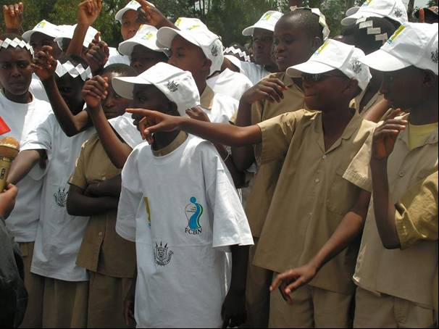
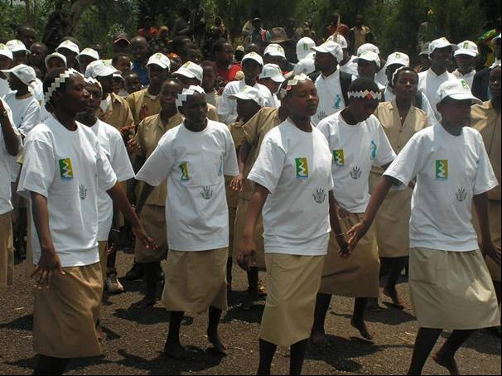

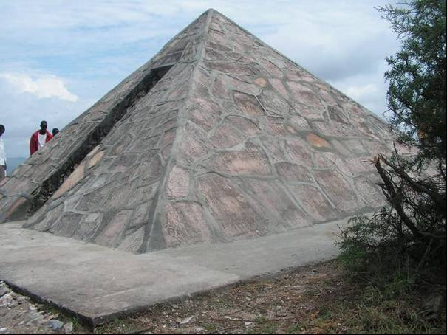

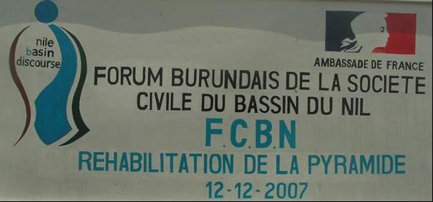

The Nile day celebration in Burundi was held at the Burundi Source of Nile, the southern source of all, located in Rutovu Commune, Bururi Province (in the South of the country).
The ceremonies were jointly organized by the Burundi NDF and NBI-CBSI project (see attached planned activities for the day), in conjunction with the Burundi Ministry in charge of water (Ministry of Water, Energy and Mine). The National Tourism Office was also associated in the preparations for the Rutovu site is a tourist site.
High ranking authorities were invited to join the celebration, among which Ministries in charge of environment, home affairs, foreign affairs and tourism. French and Germany Embassies were also invited for they have funded refection and rehabilitation activities for the Nile Source and the Pyramid constructed by a German citizen who discovered the source of Nile. Of course Burundi NDF member organizations have been invited to join the celebration, as well as local authorities, local based organisations and local primary and secondary schools.
Guests arrived at the site at around 11:00 AM, for most of them came from Bujumbura City and other Provinces of the country.

At arrival, guests got t-shirts and cups having three logos, BNDF’s, NBI’s and Burundi Government’s (see more pictures in the attached album).
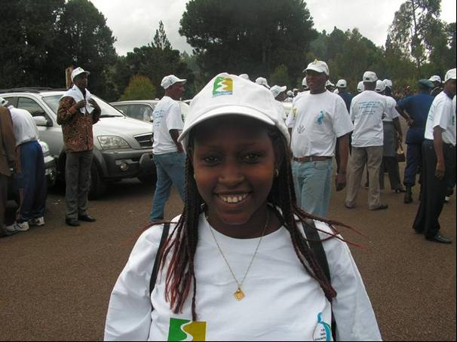
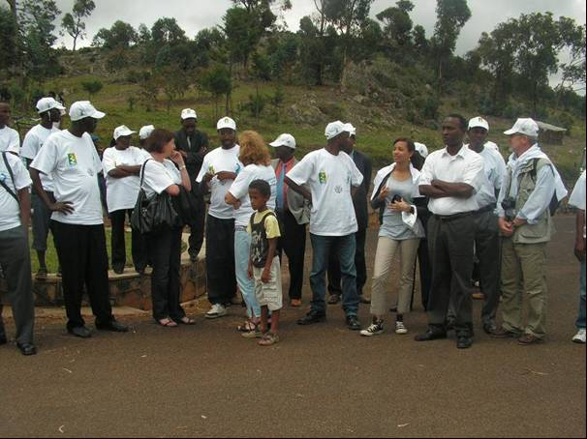

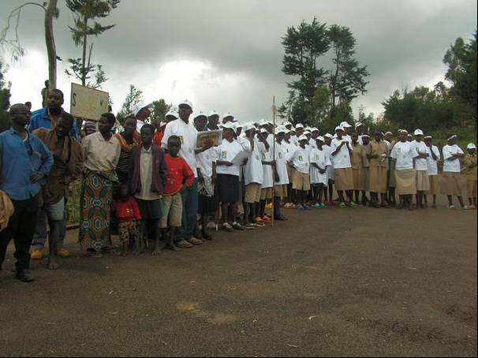
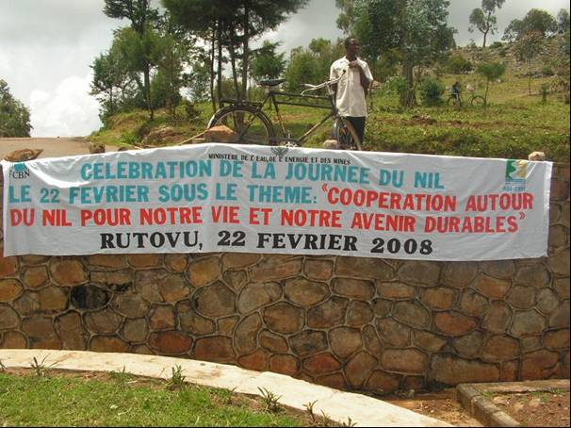

Drum players from the traditional Drum Player Association of Rutovu together with traditional dances from girl school children welcomed the guests (see more pictures in the attached album).

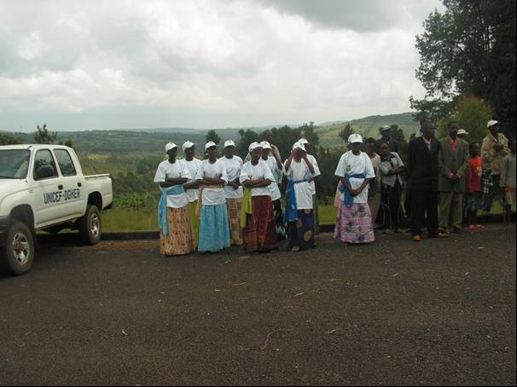
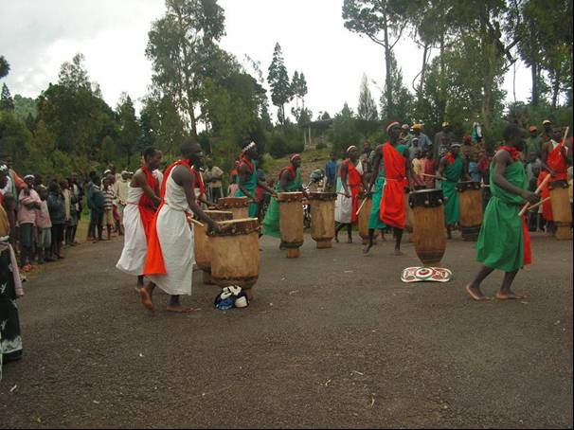

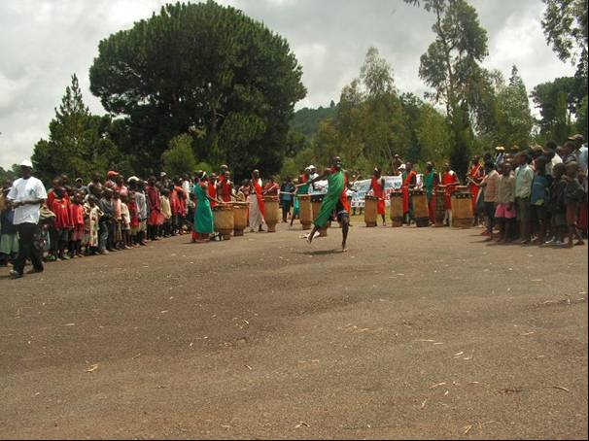
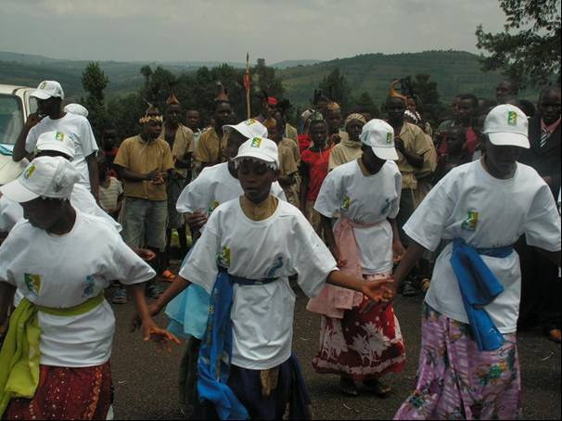

Nile day being dedicated to children, the first activity on the program was competitions among school children from four primary schools of Rutovu Commune, on general knowledge questions on the Nile, water protection and poverty reduction. The questions were of course tailored to their levels. Dance competitions among the four schools and traditional poems competitions embellished the ceremonies. Later on, the jury distributed prices to winners, and to trainers of Environment School Clubs.

Some pictures of the dances, poems and general knowledge competitions from school children.
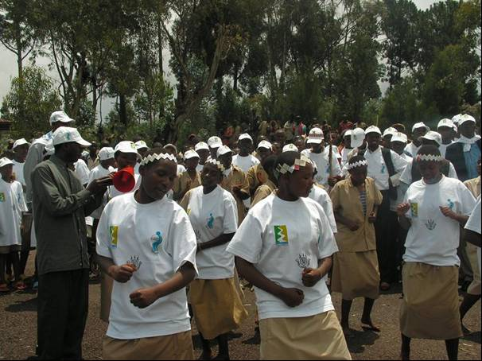
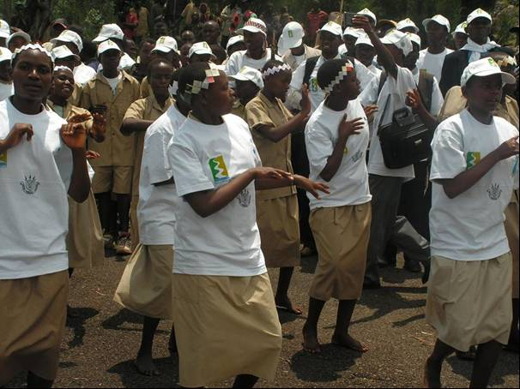

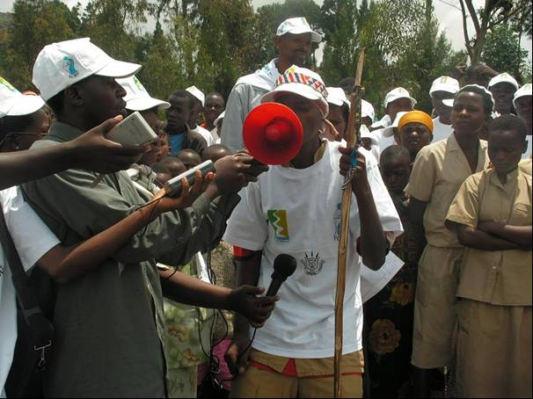
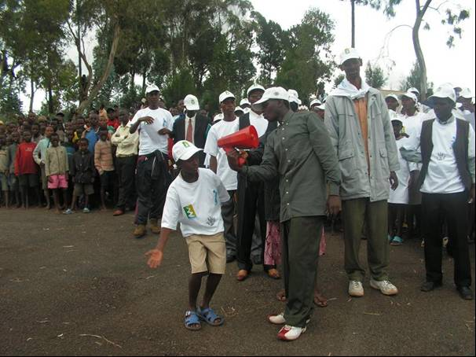

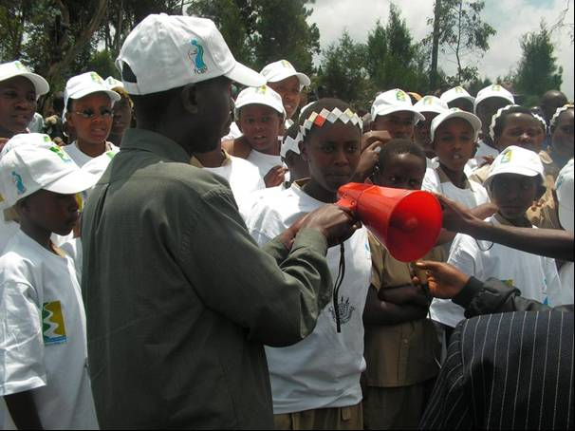
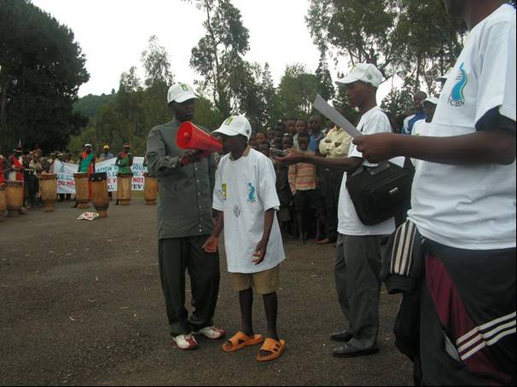

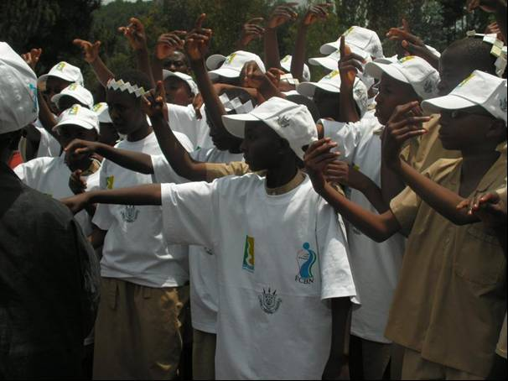
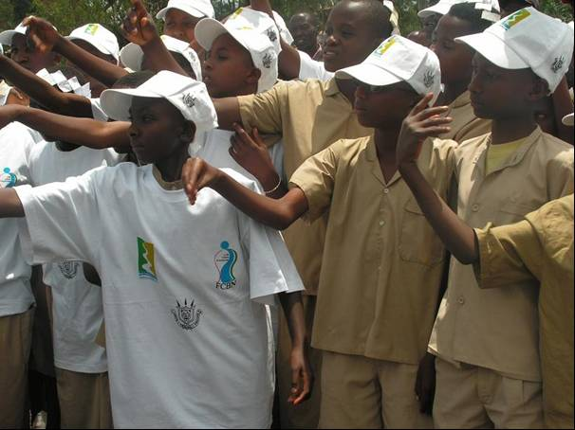

See more pictures on the attached album

Speeches of the day were pronounced respectively by the Rutovu Commune Administrator (he pronounced a welcoming speech), the Burundi NDF representative (Dr SIMBANANIYE Daniel, a BNDF SC member, pronounced the speech on behalf of the Chair who was out of the country that day), the GTZ representative on behalf of the Germany Embassy (the Germany Cooperation program funded the rehabilitation of the Source of the Nile via the Burundi NDF, and accepted to fund soon the rehabilitation of restrooms and huts for visitors refreshment). Then the Head Cabinet in the water Ministry delivered the Government message.
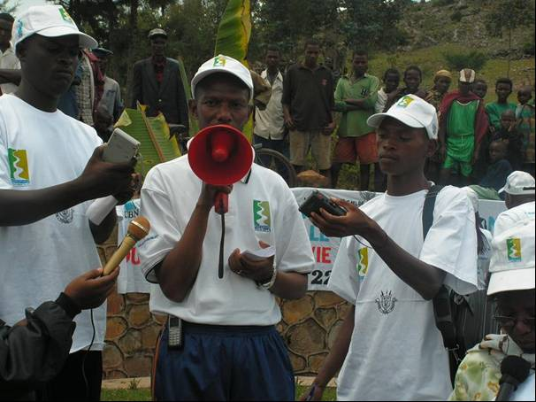

Left: The Rutovu Commune administrator giving his welcoming speech, and as the day was dedicated to children, a view of school children is provided on right.

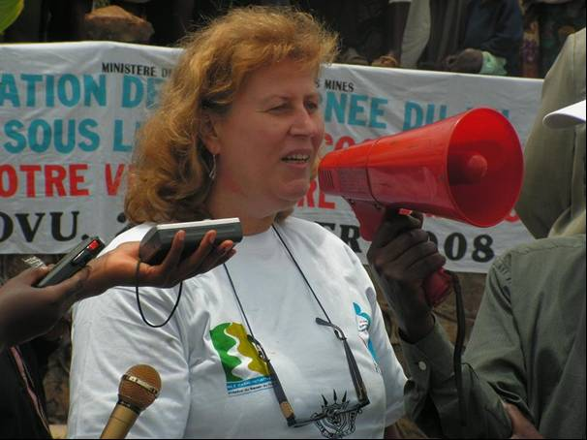
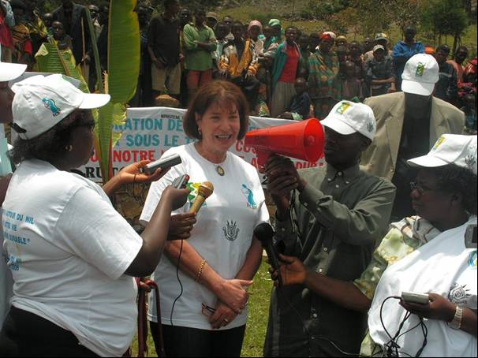

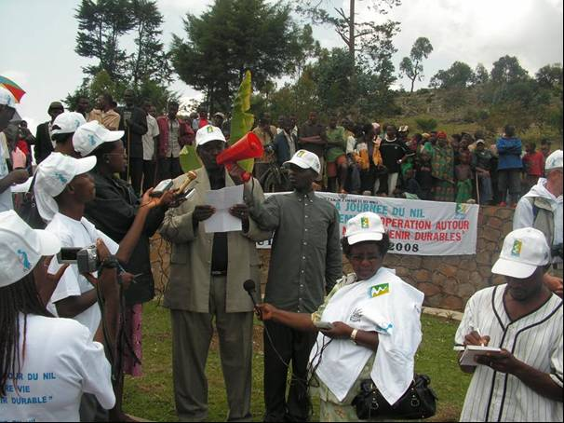
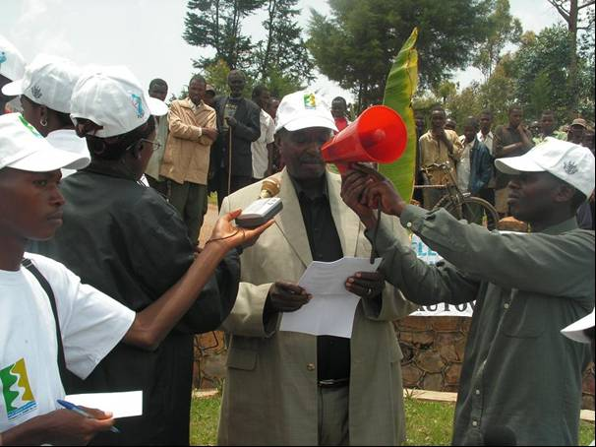

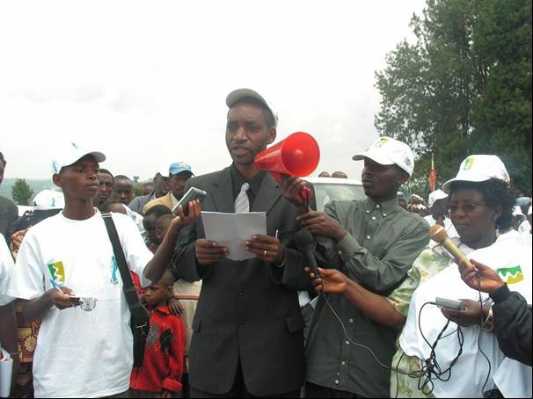

Speeches were full in colours:

1: GTZ Representative, who promised their support for the reconstruction process of the site at the Source of Nile in Burundi;
2: A representative of the Germany Embassy giving her thanking message to BNDF;
3&4: The BNDF SC representative, Dr Daniel
SIMBARUHIJE giving the speech of the day;
5: The Government representative giving a speech on behalf of the absent Minister of Water, Energy and Mine.

The following events were price distributions to students via their trainers, followed by visits that participants paid to the source of Nile in reconstruction (what is to be seen is just a start of reconstruction of the source), and to the pyramid constructed on the top of the hill where the Nile waters flow from. The pyramid was constructed by Dr Burkhart WALDECKER, who discovered the source as the southern of all in 1937.
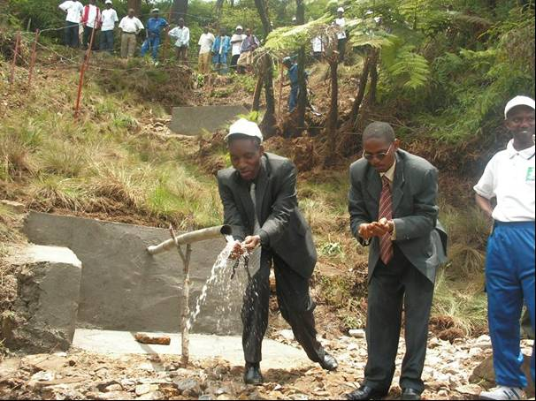
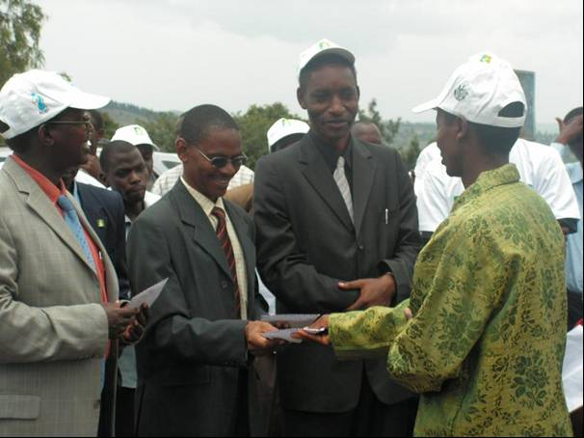

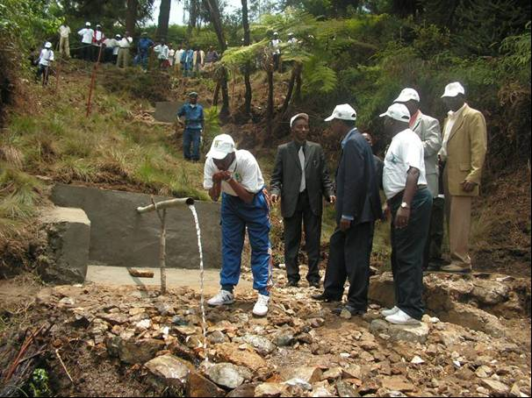

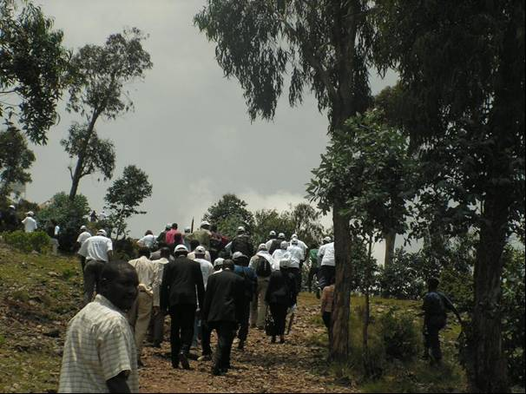

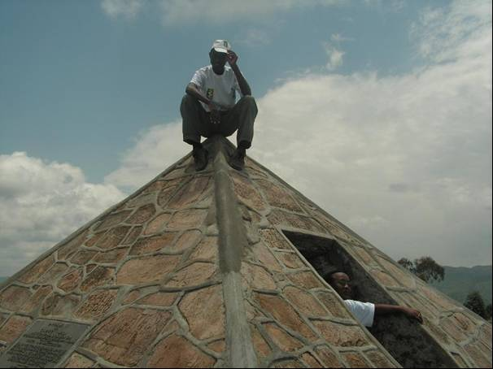

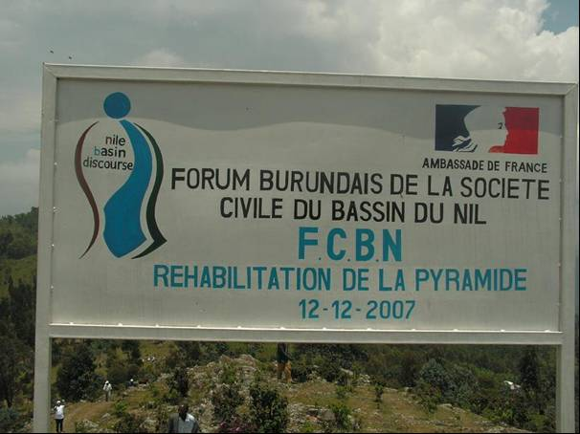

1: Price distribution by officials to competing environmental school clubs;
2&3: visit to the source of Nile and drinking on the Nile water by participants (the Administrator of Rutovu Commune, together with the Chief of Cabinet in the Water Ministry can be seen);
4: Participants heading to the top of the hill, towards the Pyramid;
5&6: The pyramid and the sign on its side to mark BNDF’s rehabilitation date.

A closing cocktail was organised on behalf of participants by the organizing committee at a nearby Motel, before they return back to their respective homes.
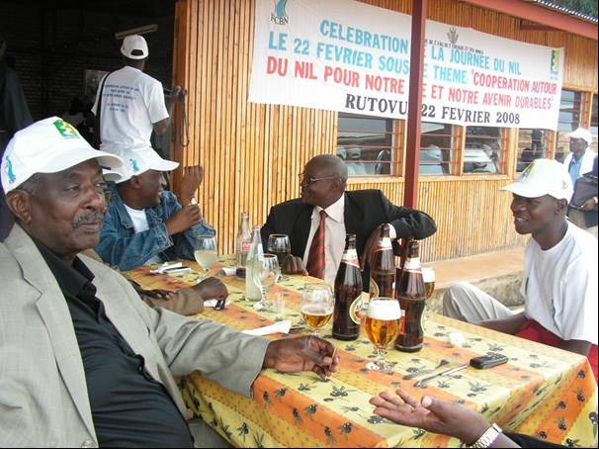

To conclude, it is clear that a big role was played by Burundi NDF both in the preparation and the realization of activities planned on the Nile Day. More illustrating pictures are on the separate album to this attachment, and a film of the events has been taken, and a copy of it will be available soon.

PROCES-VERBAL DE LA REUNION DE COORDINATION DES ACTIVITES DE L’IBN TENUE AU BUREAU NATIONAL DE L’IBN EN DATE DU 30 MAI 2008.

I.INTRODUCTION

La visibilité de l’IBN au niveau national repose largement sur la façon dont les citoyens perçoivent l’Organisation et aussi sur la façon dont cette Organisation met en œuvre son mandat..
L’importance de la Coordination Nationale a été reconnue par les Membres du TAC dans leur réunion du 18-19 Octobre 2004. Cette position des TAC a été endossée par la neuvième Réunion du Conseil des Ministres du Nil(Nile-COM) de la même année. Pour
mettre en œuvre cette décision ,le Nile-COeM a recommandé l ’établissement des Bureaux Nationaux de l’IBN dans tous les pays pour assurer la coordination des activités de l’IBN
Les Programmes SVP et SAPs sont aujourd’hui à la vitesse de croisière, dans leur exécution. La situation actuelle de ces Programmes fait que la Coordination soit encore plus urgente.
En Mars 2007 ,le Nile-TAC a mandaté le Directeur Exécutif de l’IBN de préparer une stratégie pour renforcer la Coordination des activités de l’IBN dans les pays membres.
C’est donc suite à ces décisions qu’une réunion de Coordination de tous les membres des Comités de pilotage et des Coordinateurs Nationaux des Projets a été organisée en date du 30 Mai 2008 dans le Bureau National de l’IBN sous la direction des TAC.

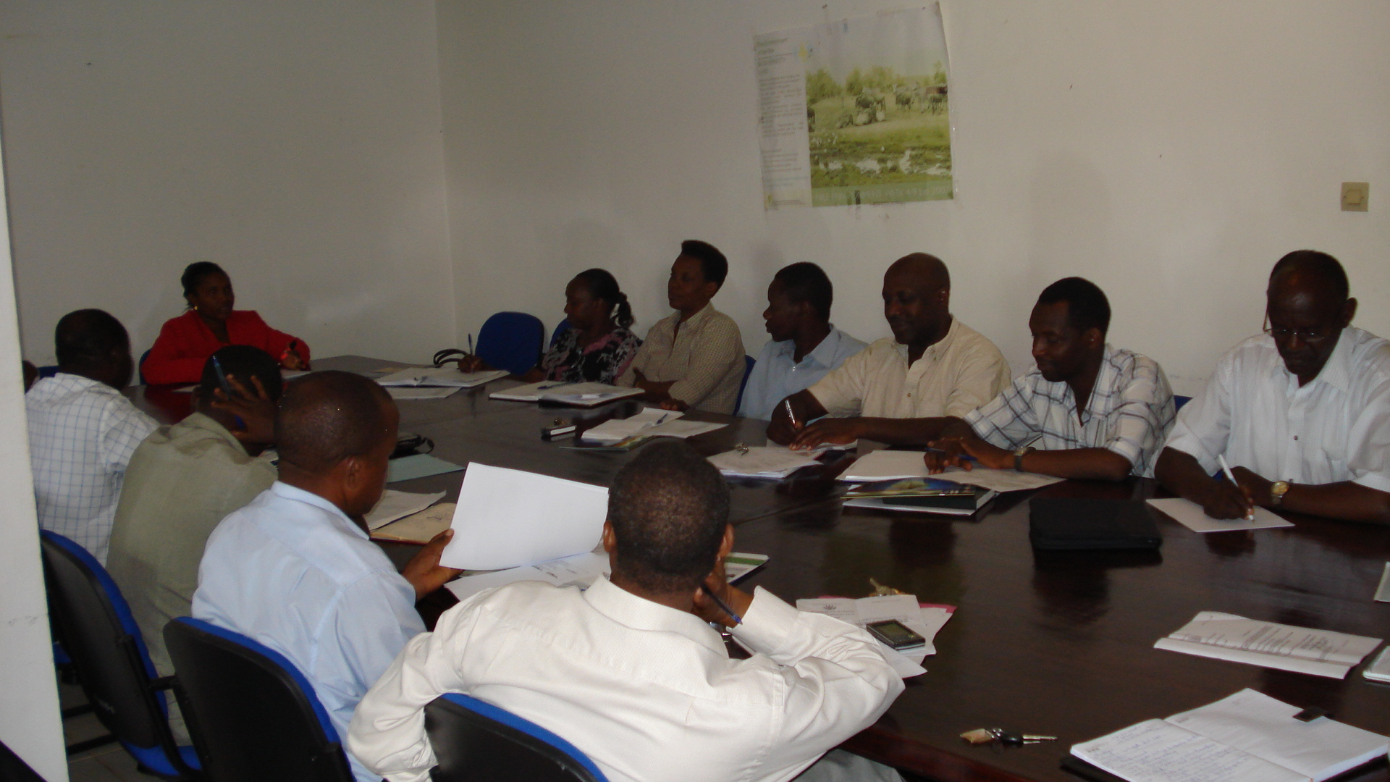 | 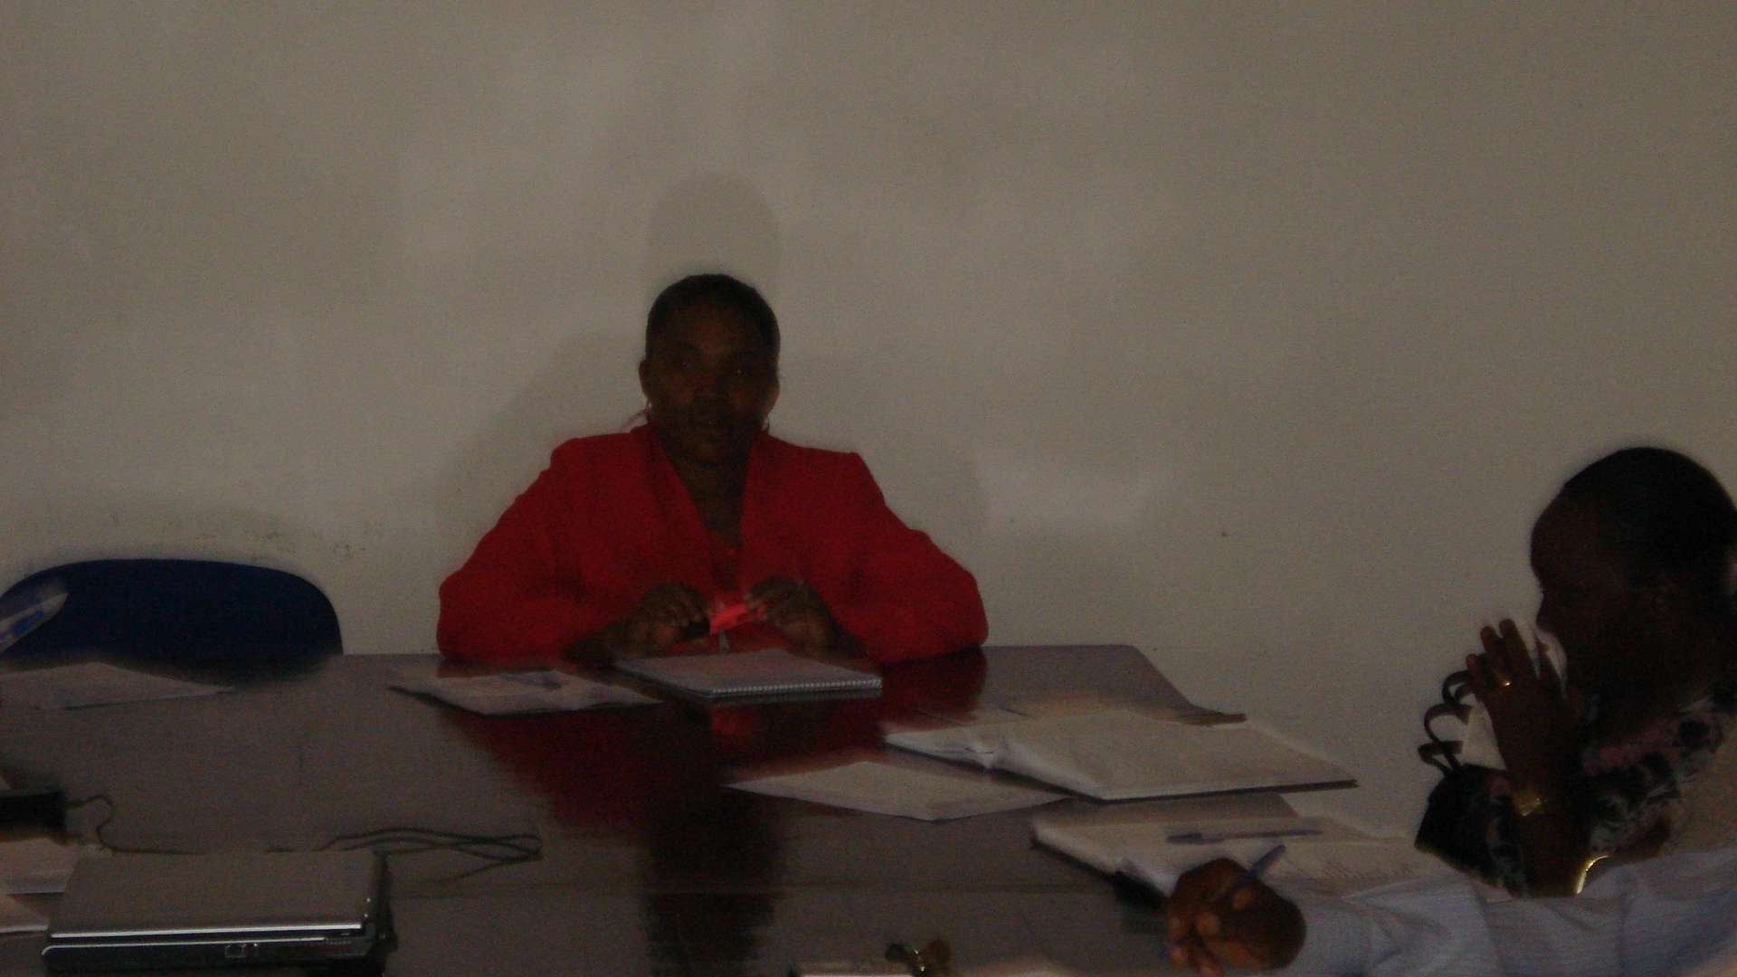
View of the Participants | Mme Odette Kayitesi chairing the Meeting

Les points inscrits à l’ordre du jour sont les suivants :

1. Prise de contact avec les nouveaux TAC/BURUNDI
2. Brève présentation des réalisations des projets SVP/PSA par les Coordinateurs
Nationaux.
3. Finalisation de la Stratégie Nationale de Coordination
4. Présentation de ISP
5. Divers

II. DEROULEMENT DE LA REUNION
Les points prévus à l’ordre du jour sont :
Les activités de coordination partie intégrante du Plan d’actions du Projet CBSI(activité 1.2.2.3)
La réunion du 30 Mai a été convoquée ( lettre n°762.0/79/2008 du 20 Mai 2008)
et présidée par les Membres du TAC
La liste des invités est en annexe.

La réunion était présidée par Madame Odette Kayitesi ,DG IGEBU et Membre du
T AC
1. Prise de contact avec les nouveaux membres du TAC pour le Burundi
Les deux membres du TAC ont été désignés par le Ministre de l’Eau,de l’Energie et des Mines par sa lettre n° 760/CAB/221/2008 du 10 Mars 2008 suite aux changements intervenus au niveau de la dénomination des Ministères (cfr Décret n° 100/314 du 14 novembre 2007) .
Les nouveaux membres du. TAC sont Mr. IDI Buhanga Pressadi,Directeur Général de l’Eau et de l’Energie et Madame Odette KAYITESI, Directeur Général de l’IGEBU.

2. Légalité de la réunion
La nomination des nouveaux membres du TAC n’a pas été facile.
L’invitation à la réunion étant émise par le nouveau TAC,sa légalité a été posée aux participants. Les éclaircissements qui ont été fournis ont été acceptés.

Recommandation
- Faire un plaidoyer au niveau du Ministre de l’Eau ,de l’Energie et des Mines et du Ministre de l’Environnement,de l’Aménagement du Territoire et des Travaux Publics pour résoudre cette question urgente.

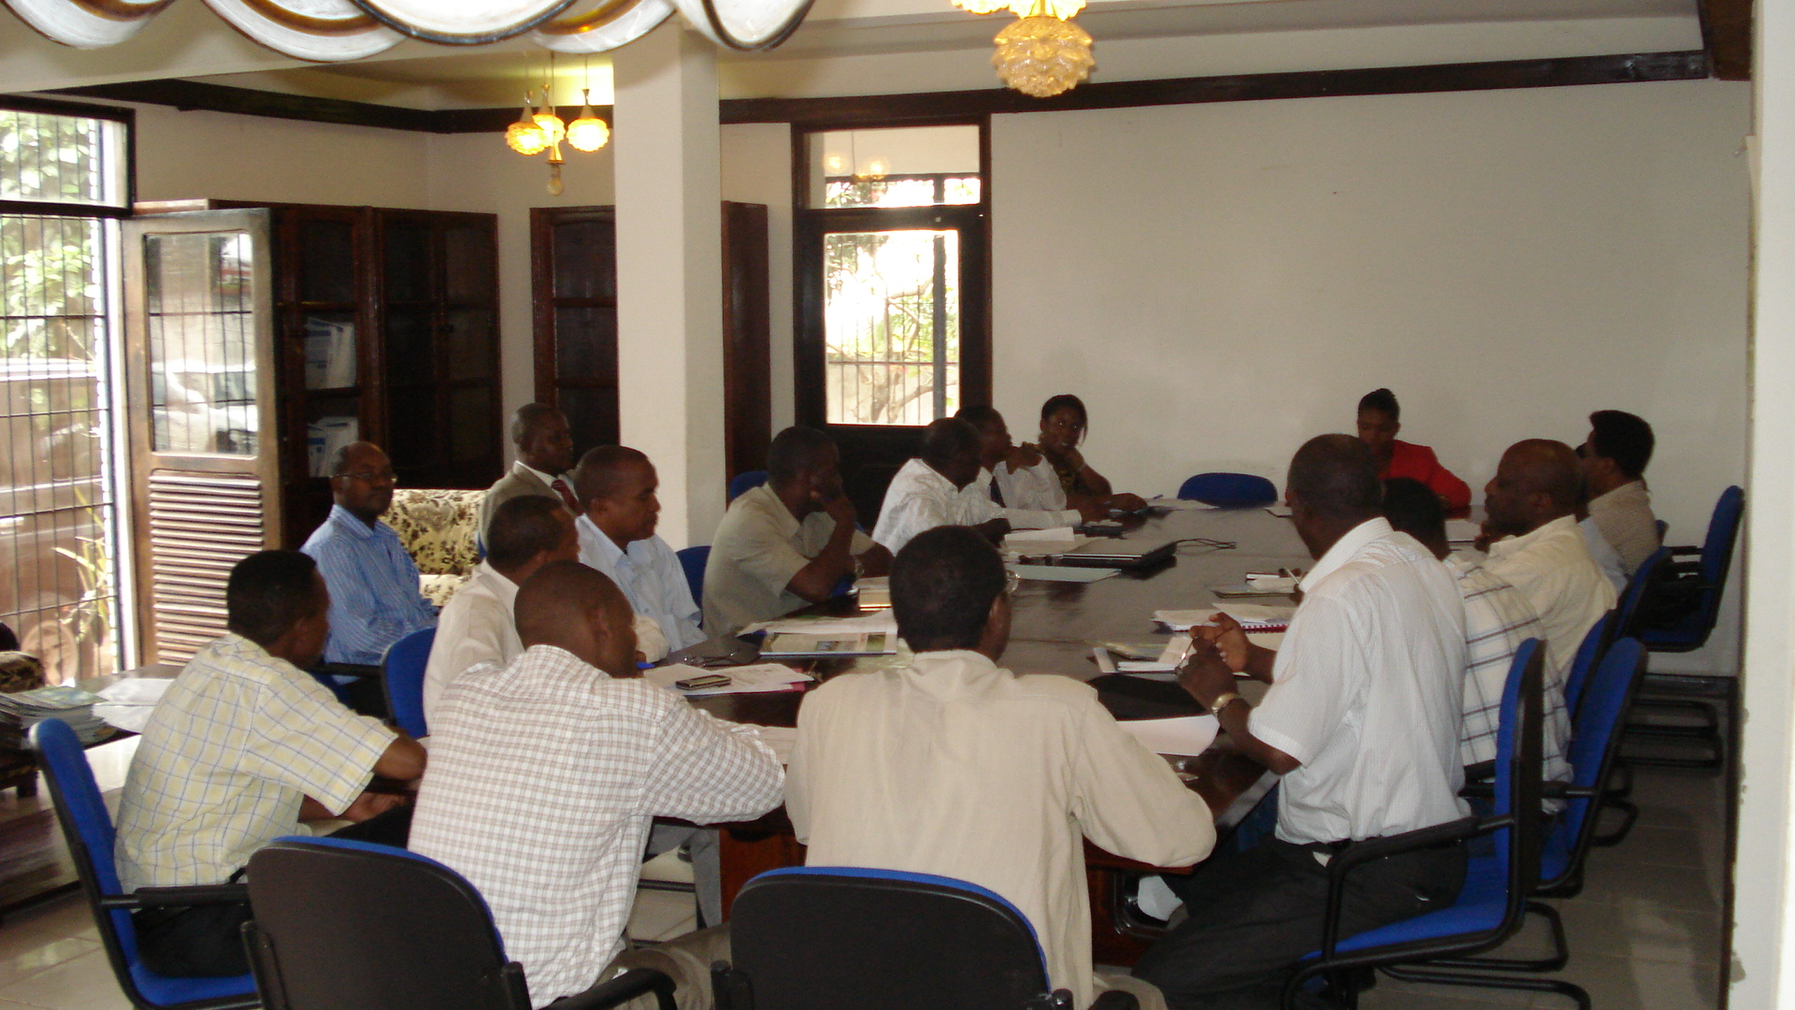
Coordination Meeting Chaired by Odette Kayitesi, TAC, 30th May, | Participants to the Meeting in NBI National Office

2. Brève présentation des4 réalisations des Projets SVP/SAP par les Coordinateurs
Nationaux
2.1 . Projet Formation Appliquée à la Gestion Intégrée des Ressources en Eau
Le Coordinateur National du Projet ,Madame Nusura HASSAN a présenté les réalisations du Projet en termes de formations de troisième cycle(niveau MSC et PhD ) et formations de courte durée. La désignation des candidats nécessaires au cours de courte durée par les autorités Administratives ne se conforme pas au niveau de formation requise aux besoins et aux résultats escomptés . En effet ,les candidats désignés sont souvent de niveau de formation supérieure ou quelques fois les candidats ont déjà participé à ce type de formation.
Recommandation
R1 : Publier les appels à la candidature pour avoir les candidats qu’il faut ,
R2 : Demander les candidatures avec un cahier de charge
R3 : Inventorier les Ressources Humaines disponibles dans le secteur de la Gestion de l’Eau et de l’Assainissement et recommander au Gouvernement un Plan de formation pour pouvoir être compétitif au niveau des autres pays de l’IBN et EAC .
Une Commission a été désignée pour faire ce travail.,il s’agit des services de :
- Eau et Energie
- Regideso
- IGEBU
- Agiculture
- Environnement
- DSS
- CBSI
- NTEAP

R4 : Les participants ont insisté sur la nécessité de réserver le temps qu’il faut aux réunions de coordination pour leur permettre d’épuiser toutes les questions liées à la Coordination des projets de l’IBN.

Clôture de la Réunion
La réunion a été clôturée à 13h00. La prochaine réunion devrait avoir lieu à la fin du mois de Juin 2008.

LE RAPPORTEUR ,
Denis Barandemaje,NPC/CBSI

